EXTRACTION: Zero Hour
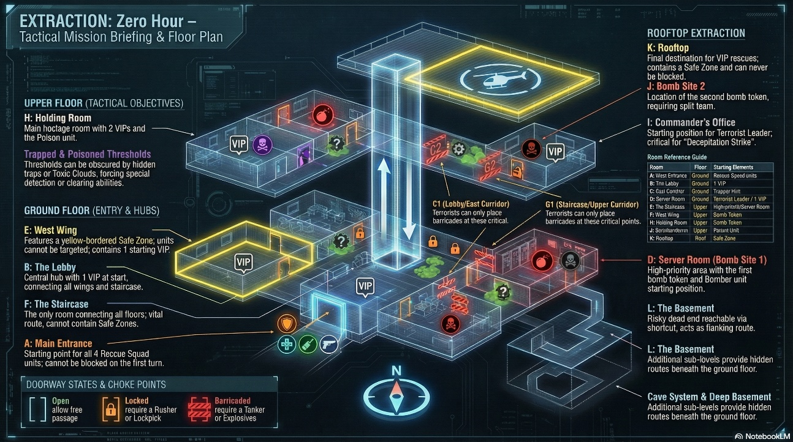
This is a 2-player asymmetric tactical game where one player is the Rescue Squad and the other is the Terrorist Cell.
Based on the game design document and the AR holographic visualization you shared, we are going to build a tense, 45-75 minute experience. Here is your step-by-step master guide to building the board, systems, and mechanics in simple English.
Phase 1: Building the AR Board Visualization
Look at the AR image you provided. We will build a 3D isometric, multi-level projection on a digital tabletop. The board has 4 floors connected by a central stairwell.
- The UI (User Interface): Add a "Tactical AR View" menu at the bottom so players can click to focus on the Rooftop, Upper Floor, Ground Floor, or Basement. Include glowing legends for VIPs, Bomb Sites, Safe Zones, and Door States.
- Ground Floor: Build the Main Entrance (Room A) where the Rescue Squad spawns. Connect it to the Lobby (Room B), the East Corridor (Room C), the West Wing / Safe Zone (Room E), and the Primary Server Farm (Room D) which holds Bomb Site 1.
- Upper Floor: Build the Upper Corridor (Room G) leading to the Holding Room (Room H) where hostages are kept, the Commander's Office (Room I) where the Terrorist Leader spawns, and Bomb Site 2 (Room J).
- Basement & Roof: The Deep Basement (Room L) is a hidden route from the servers. The Rooftop (Room K) features helipads for extracting VIPs and acts as a safe space.
Phase 2: Generating the Digital Components
You need to program the following digital assets:
- Unit Tokens: 4 Rescue units (Orange, Green, Blue, White) and 4 Terrorist units (Red, Dark Grey, Black, Purple).
- Tokens: 6 numbered VIP chips, 4 Bomb tokens, 12 Bomb Countdown Markers, 5 Trap tokens, 3 Poison Clouds, 4 Barricades, and 4 Hostage Shields.
- Cards: A deck of 16 Secret Goal Cards (8 per team) and a 50-card deck of Movement and Action cards (25 per player).
- Dice: Two digital 6-sided dice (d6).
Phase 3: The 12-Step Setup Process
Program the game to automatically run these 12 setup steps before Turn 1:
- Spawn the holographic board in the center.
- Place "Locked Door" tokens on all doors with a padlock symbol.
- Place all 4 Rescue units at the Main Entrance (Room A).
- Place Terrorist units: Bomber in Server Room (D), Trapper in East Corridor (C), Leader in Commander's Office (I), and Poison in Holding Room (H).
- Randomly spawn the 6 VIP tokens in Rooms B, E, H (x2), I, and one random room.
- Place Bomb tokens in Room D and J. Set their countdown trackers to 5.
- Secretly deal 1 Rescue Goal Card to the Rescue player.
- Secretly deal 1 Terrorist Goal Card to the Terrorist player.
- Give each player 25 Movement/Action cards.
- Set the Round Counter to 1 (the game ends at Round 20).
- Give each player a digital d6 and 2 Ability Cooldown tokens.
- The Rescue Squad takes the first turn!.
Phase 4: Core Turn Mechanics
The game relies on a 4-step turn system. Diagonal movement is never allowed. Players take turns one at a time.
- Phase 1: Roll the Die. The player rolls a d6 to get their "movement budget" for the turn.
- Phase 2: Play a Card. The player must play 1 card. Movement cards add extra points to the dice roll, which can be split among units. Action cards trigger special events without giving movement. Note: If a player's hand is empty, they must draw 3 cards from their discard pile and skip Phase 3 as a penalty.
- Phase 3: Use an Ability (Optional). The player can activate one unit's special power. If used, place a Cooldown Token on that unit for 2 turns.
- Phase 4: Resolve Effects. The system must check in this exact order: 1) Traps triggered, 2) Bombs exploding, 3) Poison effects, 4) Goal Card completions, and 5) Round Advance (after both players finish their turns, move the round counter and tick down active bombs by 1).
Phase 5: Asymmetric Character Systems
Code completely different mechanics for the two teams.
The Rescue Squad (India's Elite Forces):
- Rusher: Can use "Sprint Breach" to ignore the dice, move 5 spaces, and permanently break Locked Doors.
- Sniper: Uses "Overwatch" to pin enemies from 8 spaces away (in a straight line) and automatically detects hidden traps/bombs nearby.
- Tanker: Has 2 HP. Uses "Armoured Breach" to break Barricades and can roll the dice to defuse Bombs.
- Medic: Uses "Field Revive" to bring back eliminated teammates and automatically clears Poison Clouds by walking onto them.
The Terrorist Cell (Control and Trap):
- Bomber: Can use "Remote Detonate" to speed up a bomb's countdown by 2 ticks, or plant a new bomb.
- Trapper: Places hidden face-down trap tokens that weaken, pin, or eliminate Rescue units who step on them.
- Leader: Uses "Rally Cry" to give free movement to teammates and places Hostage Shields on VIPs so they cannot be rescued.
- Poison: Drops "Toxic Clouds" that weaken Rescue units (-1 movement).
Phase 6: Special Rules to Program
Do not miss these crucial backend systems:
- Goal Cards: This is the only way to win. A player wins instantly if they complete their hidden card (e.g., Rescue saving 3 VIPs, or Terrorist detonating both bombs). If nobody wins by Round 20, the team with the most rescued VIPs wins.
- The Bomb Clock: Bombs count down from 5 to 0. At 2-3 (Critical), the Terrorist can detonate for free. At 0, everything within 2 spaces is eliminated.
- Combat: If the Rusher ends on an enemy space, trigger a "Direct Assault" dice roll to see who gets hurt. If a Terrorist moves onto a Rescue unit, trigger a "Terrorist Direct Encounter" dice roll.
- Carrying VIPs: When a Rescue unit steps on a VIP, they pick them up. Their movement becomes -1. To rescue them, the unit must carry the VIP to the Rooftop (Room K).

AR Tactical View menu
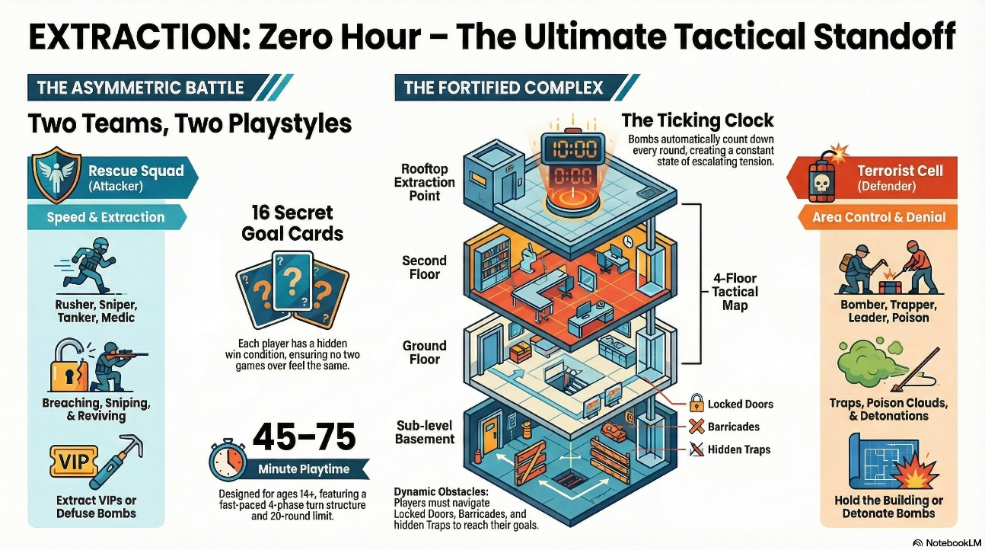
1. The Instruction Prompt At the bottom left of the AR interface, code a text box that says: "TACTICAL AR VIEW: Click a floor to focus, or any room for details." This tells the players that the board is fully interactive.
2. The Floor Selection Buttons Just below the instruction text, program a row of clickable, glowing buttons to act as camera filters. When a player taps one of these buttons, the AR projection should isolate and focus on that specific level of the 3D map. Code these exact five buttons:
- ROOFTOP
- UPPER FLOOR
- GROUND FLOOR
- BASEMENT
- B1 / CAVES
3. The Holographic Legend Along the very bottom edge of the screen, under the floor selection buttons, you need to build the icon legend. This is crucial so players can instantly understand the glowing symbols on the board. Code the UI to display these exact labels and their matching icons:
- VIP (Yellow person icon)
- BOMB SITE (Red bomb icon)
- SAFE ZONE (Green leaf/shield icon)
- LOCKED DOOR [x] (Red door with an X)
- UNIT SPAWNING (Blue icon)
- BARRICADE (Red striped icon)
- DOOR STATES (Blue door icon)

Gameplay storyboard
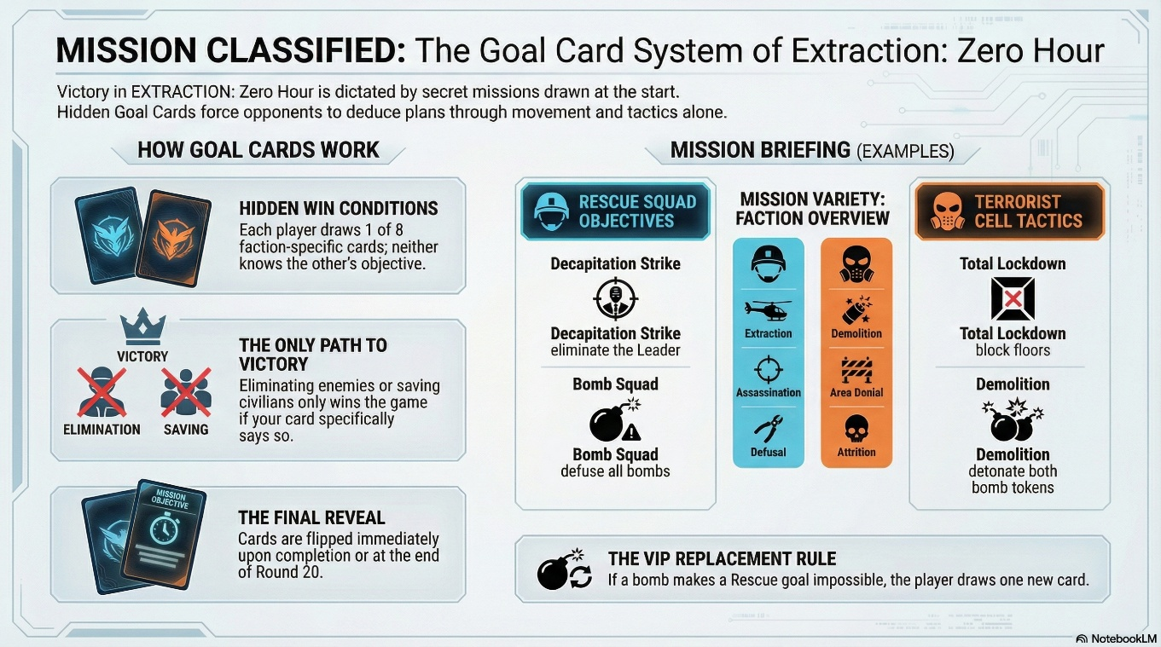
EXTRACTION: Zero Hour.
Scene 1: The Holographic Briefing (Setup)
- Visual: The digital tabletop powers on. A glowing 3D blueprint of the 4-floor Fortified Complex builds itself in the center of the table. The bottom UI loads the TACTICAL AR VIEW menu.
- Action: The game automatically executes the 12-step setup.
- AR Elements: Blue spawn rings appear at the Ground Floor Main Entrance (Room A), dropping in the 4 Rescue Squad operators (Rusher, Sniper, Tanker, Medic). Across the building, red enemy signatures appear as the Terrorist units spawn in the Server Room, Commander's Office, East Corridor, and Holding Room.
Scene 2: The Breach (Turns 1-3)
- Visual: The camera focuses on the Ground Floor. The Rescue player rolls their digital d6 and plays a "+2 Move" card from their hand.
- Action: The Rescue player activates the Rusher (Orange). Using the "Sprint Breach" ability, the Rusher ignores the dice roll, dashes 5 spaces, and permanently breaks the Locked Door leading into the Lobby (Room B).
- AR Elements: A holographic shattering effect plays as the Locked Door icon [X] vanishes from the AR map.
Scene 3: The Terrorist Counter-Measure (Mid-Game)
- Visual: The board glows with a purple and dark grey tint as the Terrorist player takes control.
- Action: The Terrorist player uses the Leader's "Rally Cry" ability to give free movement to their team. Then, the Poison unit (Purple) drops a Toxic Cloud token right on the central Stairwell (Room F).
- AR Elements: A green, animated gas cloud fills the Stairwell hologram. Any Rescue unit that tries to climb to the Upper Floor will now be "Weakened" (-1 movement).
Scene 4: The Ticking Clock (Bomb System Escalation)
- Visual: The room lights dim slightly, and the AR board pulses with a red warning light.
- Action: The Round Counter advances, and the active Bomb in the Primary Server Farm (Room D) ticks down. It hits the "Critical" state (only 1-2 markers left).
- AR Elements: The UI announces "BOMB CRITICAL". The Terrorist Bomber now has the power to use "Remote Detonate" for free, forcing the Rescue player to panic and send their Tanker (Blue) to roll a d6 and attempt to defuse it.
Scene 5: The Extraction (The Climax)
- Visual: The Tactical View shifts focus to the Upper Floor and Rooftop (Room K).
- Action: A Rescue unit successfully steps onto a numbered yellow VIP token in the Holding Room (Room H) and picks them up. Moving slowly (at -1 movement speed), the operator carries the VIP up the stairs to the Safe Zone on the Rooftop.
- AR Elements: As the unit reaches the Helipad on the Rooftop, a holographic extraction chopper drops a zipline, visually confirming the VIP is rescued.
Scene 6: The Reveal (Game Over)
- Visual: The game pauses. Both players are prompted by the system to reveal their secret Goal Cards.
- Action: The Rescue player flips over Goal Card G1: Priority Extraction (Rescue at least 3 VIPs to the Rooftop before Round 18). They have achieved their goal!
- AR Elements: The Terrorist holograms dissolve into static. The AR board displays a massive "MISSION ACCOMPLISHED" banner over the Helipad, celebrating the Rescue Squad's strategic victory.

The Win logic
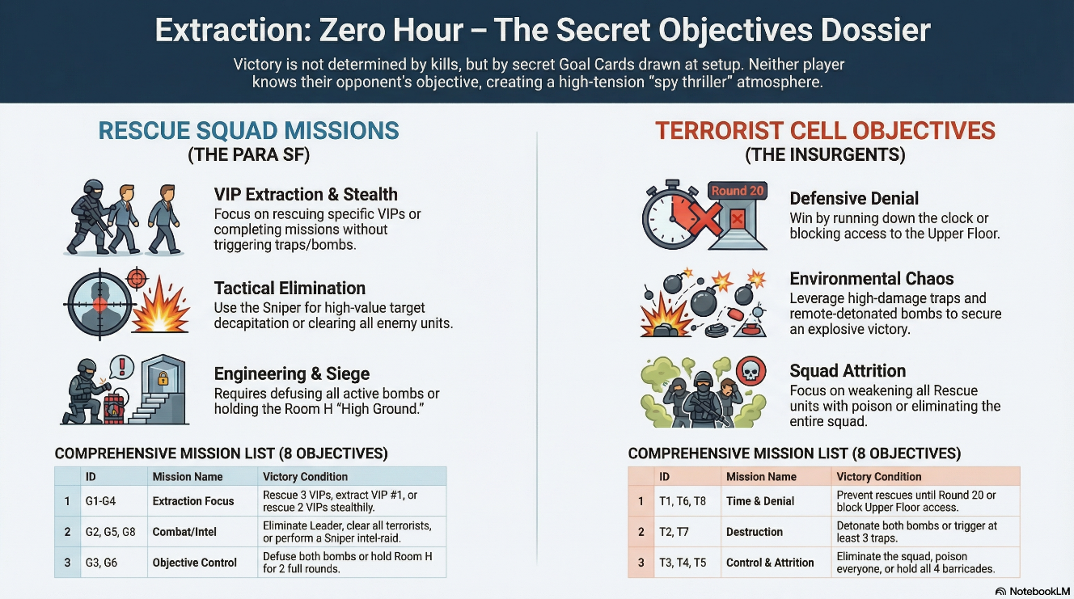
Part 1: The Digital d6 Dice Logic (Phase 1)
At the start of a player's turn, they roll their digital 6-sided die. This creates their "movement budget" for the turn, which can be split among any of their active units.
You must program two critical special conditions into the dice logic:
- If the roll is 2, 3, 4, or 5: Standard result. The number rolled equals the base movement points available.
- If the roll is a 1 (Critical Low): The player gets only 1 movement point, but the system must automatically prompt them to draw 1 extra card from their discard pile.
- If the roll is a 6 (Critical High): The player gets 6 movement points. Additionally, the system must grant a free 1-space bonus move with any unit, which must be taken after their main action.
Part 2: The Card Playing Logic (Phase 2)
Each player starts the game with their exact deck of 25 cards. The system must enforce that a player must play exactly 1 card during Phase 2. You need to program two different logic branches depending on the card type played:
- Branch A: Movement Cards (30 in the deck): If a movement card (like +1, +2, +3, or +4) is played, the system takes the value of the card and adds it to the dice roll. For example, if the dice roll is 3 and the card is +2, the total movement budget becomes 5 spaces. The player can then split these 5 spaces between any of their units.
- Branch B: Action Cards (20 in the deck): If an action card (like Lockpick or Flashbang) is played, it does not add any movement points. The movement budget remains exactly what the dice rolled, and the system immediately executes the card's special effect.
Part 3: The "Empty Hand" Refresh System
Because players do not automatically draw cards at the start of their turn, their hands will eventually run empty. You need to program this specific penalty protocol when a player has 0 cards left in their hand:
- Check Hand State: At the start of Phase 2, if Hand == 0, trigger the Refresh Protocol.
- Shuffle and Draw: The system must automatically shuffle that player's discard pile and draw exactly 3 cards back into their hand.
- Apply the Penalty: The system must forcibly skip Phase 3 for that player this turn, preventing them from activating any powerful Special Abilities (like the Terrorist Leader's Rally Cry or the Rescue Medic's Field Revive)

